Museum of Bus Transportation Board of Directors Meeting 5 21/2019 7PM

Board Members Present:

John Oakman
David Schmidt
Dave Millhouser
John Dockendorf
Jimmy Hall
Bob Smith
Howard Nice
Dino Mandros
Mark Szyperski
Becky Tollens
Tom Collins
Elizabeth Deffer

Advisers Present:

Michael Burshtin
Terry Cosentino
Walter Earl
Ken McNelis
Ed Wolf
Mark Watson
Ralph Fetrow

Guests Present:

Charles Beckley
Jeff Bliemeister AACAM

Secretary Dave Millhouser declared a quorum Tom Collins moved we accept the minutes of the May 21 meeting, Mark Szyperski seconded and motion passed unanimously.

President John Oakman opened by thanking everyone involved in Spring Fling, which appears to be our biggest ever, in terms of attendance.

MOBT’s audited financial report had been sent to the Board and Advisers, showing a substantial loss for 2018. Dave Millhouser moved, and Bob Smith seconded, a motion to accept the statement so Ed Wolf could file it with the State

Ken McNelis felt that the $12K reported spent on bus repairs was not accurate… too high.
Becky Tollens questioned amount spent on “meetings and gathering” and “member services”. Thinks it, too, is high.

A motion to table acceptance by Mark Szyperski, seconded by Elizabeth Deffer and was passed.

Later in the meeting Vickie Wolf joined the discussion and provided a copy of the MOBT December 2018 detailed financials, which has been emailed to all Board Members. It appears to support the figures in the auditors report.

Marketing Report Mark Szyperski:

Some great press prior to the Spring Fling. Thanks to Dave Millhouser for the article in Bus and Motorcoach News, and for sending the follow up article to Larry Plachno for the National Bus Trader after article

Once it is known what is happening with the Annual Meeting, website will be changed over with updated information.

The Summer news letter has been held for the results of the vote, and any follow up information. That should go into production starting this weekend. It is expected to go to print by Mid-August.

The South-Central Board of Directors (Alabama, Georgia, South Carolina) have voted to donate $5,000.00 to the Museum of Bus Transportation.

Per Mark Watson, great activity on Facebook, lots of “likes” and “shares”

Gift Shop Manager John Dockendorf reports that sales are up significantly, approximately $850 above this time last year as of end of June, and July looks very good too.

Mr. Charles Beckley, the Attorney engaged by MOBT, reported the merger election procedure and results as outlined in letter below:
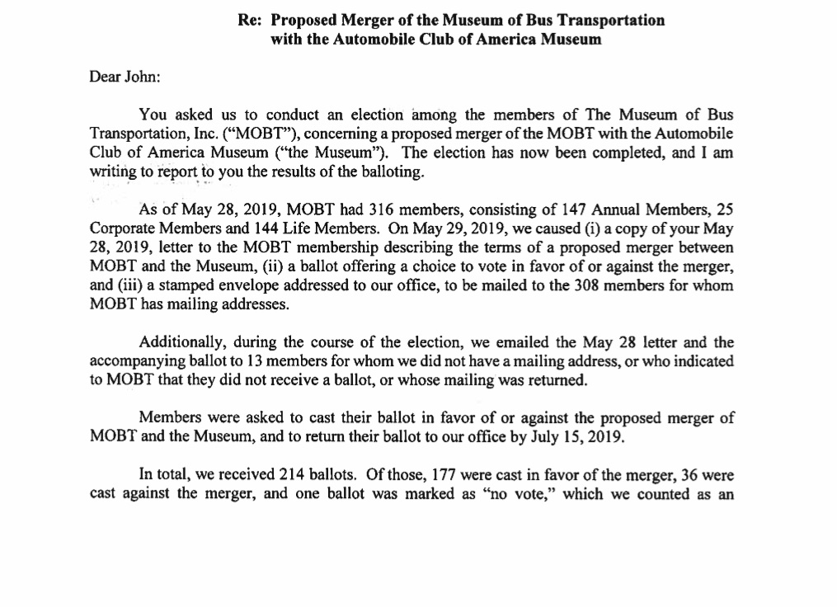

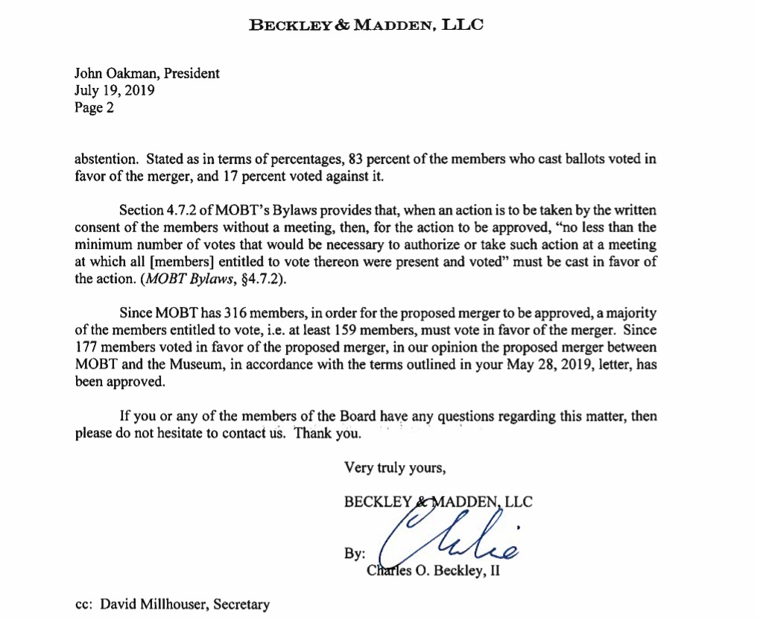
Mr. Beckley asked if there were any questions or comments, and there were none.

John Dockendorf moved that we send mailed election results to all members (in addition to emailing all for whom we have addresses), Dave Millhouser seconded, and motion passed unanimously.

Annual Meeting will be the 19th of October and John Dockendorf will head committee. Terry Cosantino and Dino Mandros will help

Terry Cosantino raised issue of personal items on loan/display at MOBT, and how we can make sure folks get their stuff back, or donate it to the AACAM. Secretary will send an email to everyone we have addresses for, letting them know to get in touch with him if they have personal items at MOBT. The Secretary will also ask Mark Watson to post letter on Facebook.

The Meeting adjourned @ 8PM

